USING OUR PARTNER PLATFORM: JOGET

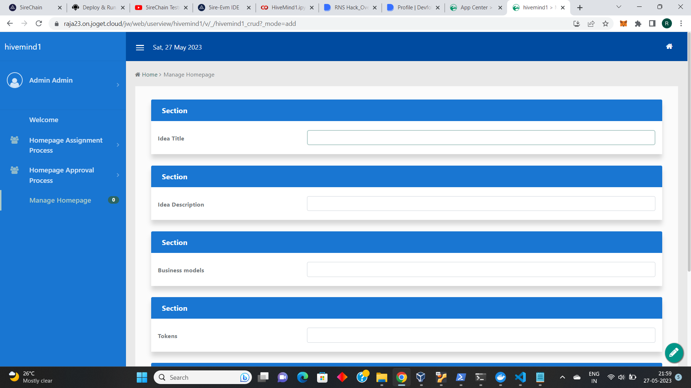

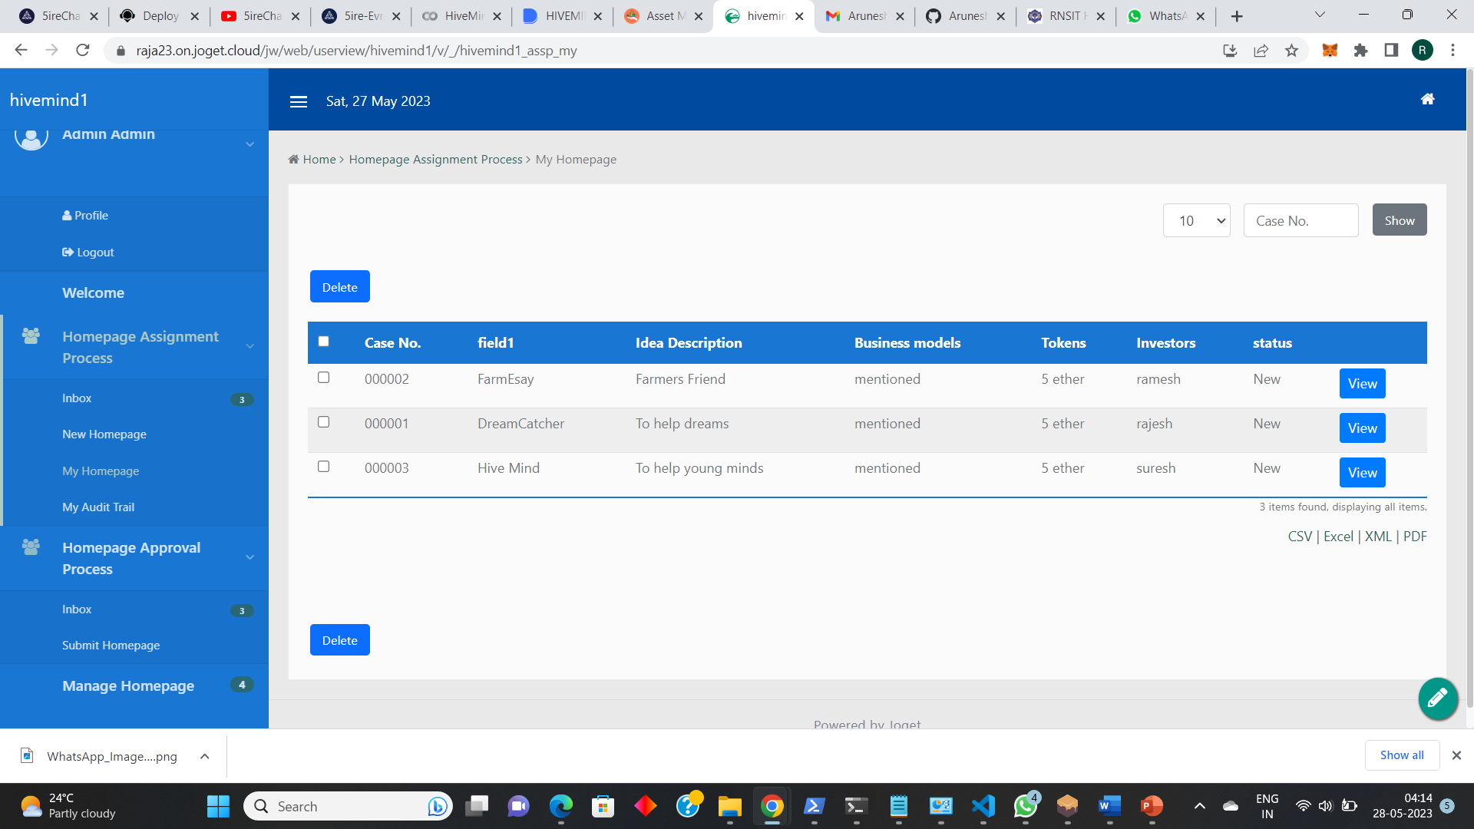

We used joget platform to add/manage assets provided by the users. With joget asset management was made easy, and we are happy to be the part of the ‘low-code no-code’ initiative.